Machine Description | A deliberately vulnerable lab machine for practicing web app exploits, privilege escalation, and post-exploitation to gain user and root access.
Target IP | 192.168.0.188
Vulnerability Name
Port / Service | TCP / http
Severity
Attack Vetor
Proof of Concept (PoC) | STEP 1 – Nmap to find the IP of the target machine.  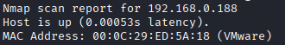  STEP 2 – Nmap Scan to discover open ports and Services  # nmap –p- -sC –sV $ip –open  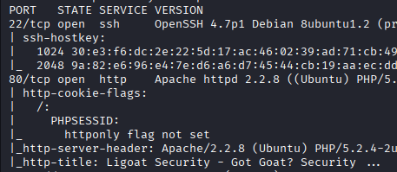  STEP 3 -Found a payload, we don’t know the version of the CMS  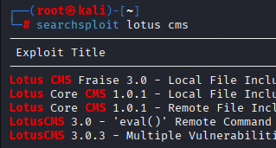  STEP 4 -After examiniting the exploit, We found that there is vulnerability in the “page” parameter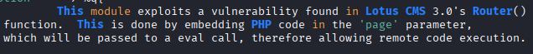  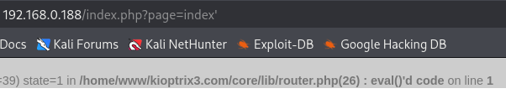  STEP 5 - After adding ‘ we got error message  STEP 6 - There is an eval() its function is to converts the string into PHP code, we captured the request in repeater and loaded the code hence we have code injection.  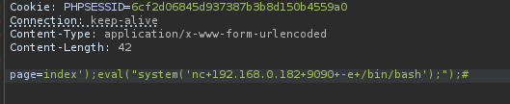  STEP 7 – Got a shell and stabilized it.  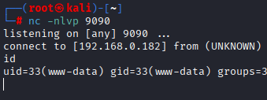  STEP 8 - Found “ht” with Guids permission  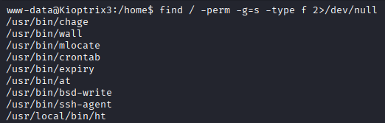  STEP 9 - Previously we found that the web root is /home/www/kioptrix3.com, we search for mysql creds  #grep –Ri ‘sq’ . –color=auto  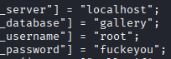  STEP 10 – Accessed the database  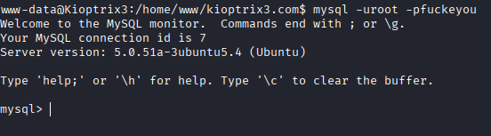  STEP 11 - Found hashes  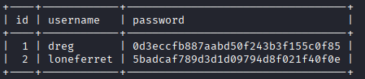  STEP 12 - cracked the hashes  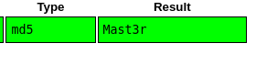  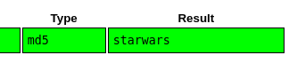  STEP 13 - Switch user to loneferret  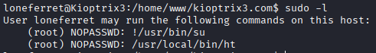  STEP 14 – We can ht as sudo without password  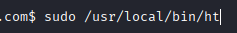  Step 15 –
Remediation
Impact
References

